

**Case R****eport**

Original Article

**Persistent Patent Urachus in an Adult, a Case Report at a Private   
Facility in Ondo City, Nigeria.**

**1Ogundiniyi S O, 1Kumolalo F O, 1Alegbeleye B J, 2Edo-Olotu F, 2Edo-Olotu E, 1Pelemo O E 1Ajekwu S C**

* Department of Surgery, University of Medical Sciences Complex Ondo **2**Christ Hospital, Ondo

Abstract

Patent urachus is a rare congenital condition in which the urachus, a tube that connects the bladder and the umbilicus in fetal development, does not close before birth. This results in a persistent communication or fistula between the bladder and the umbilicus, causing urine to leak from the umbilicus. The condition is usually diagnosed early in life. This case of a patent urachus in a 22 years old female is rare and of interest. The condition was managed by excision of the urachus and dome of the bladder. The author highlights the need for high index of suspicion so as not to miss the diagnosis in a adult since the condition can mimic varying nonspecific symptoms.

**Key words**: patent urachus, congenital anomaly.

__________________________________________________________________

**Address for correspondence author:** DR S.O Ogundiniyi, e mail sogundiniyi@unimed.edu.ng

**How to cite:** Ogundiniyi SO, Kumolalo FO, Alegbeleye BJ, Edo-Olotu F, Edo-Olotu E, Pelemo OE, Ajekwu SC, Persistent Patent Urachus in an Adult, a Case Report at a Private Facility in Ondo City, Nigeria. NJGP. 2023;21(1):52-58.

DOI: <https://doi.org/10.60787/njgp.v21i1.187>.



**Introduction**: Congenital urachal anomalies are usually diagnosed and treated in infancy because the umbilical disorder, which manifests as a discharge of urine or pus, is easily detectable. So, an adult patient with a congenital patent urachus is very rare.**1** There is no clear etiological explanation for patent urachus.**2,3** However, secretion from the epithelial lining or secondary infection of the epithelial structure seems to produce sufficient pressure to open the immature urachus.**2** In the adult population, the incidence of urachal anomalies is approximately 1 in 5000.**4**

Urinary discharge from the umbilicus in an adult could be very embarrassing. This underscores the need for treatment when diagnosed. There is also the possibility of malignancy developing in urachal remnants, although this is a rare occurrence. We present a rare case of a 22-year-old female with patent urachus.

**Case Report:**

We present the case of a 22-year-old lady in Ondo city, who presented to her primary care physician with complaints of persistent urinary discharge from her navel. This occurred whenever she had a full bladder and was aggravated by the very act of micturition. She noticed this since childhood and had been too shy to complain about it to any doctor. There were no lower urinary tract symptoms, and no associated abdominal pain. Examination revealed an inverted umbilicus with wetness upon a full bladder. Abdominopelvic ultrasound was done, which suggested a patent urachus. A micturating cytogram was also done which confirmed the ultrasound finding. The micturating cystogram had however been misplaced by the patient as at the time of filing this report. Attempts at retrieving a certified true copy of the Cystogram were unsuccessful. A cystoscopy was not done as this was not available at the private facility and for financial considerations, patient was not requested to carry out the investigation elsewhere. The lady had an open resection of the urachus with partial cystectomy. The urachus was a complete tubular fistula between the dome of the bladder and the umbilicus. The bladder was approached through a Pfannenstiel incision. The patent urachus was identified and excised with a cuff of bladder dome. Urethral catheter was left in situ for continuous bladder drainage for ten days. Recovery was uneventful and patient subsequently became asymptomatic thereafter. Histology of resected urachus and bladder cuff showed the urachus and bladder were lined with stratified columnar epithelium / urothelium, there were no areas of cellular atypia. Fig 1,2 and 3.

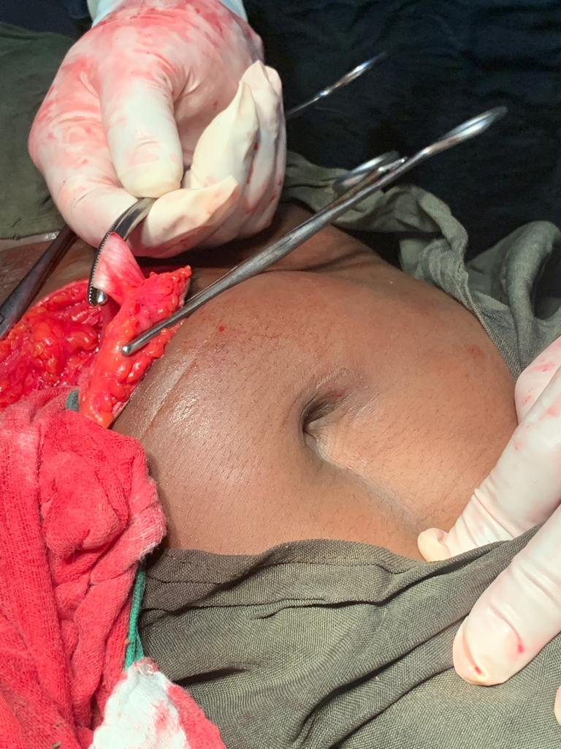

Fig. 1:The intact urachus pulling on the umbilicus.

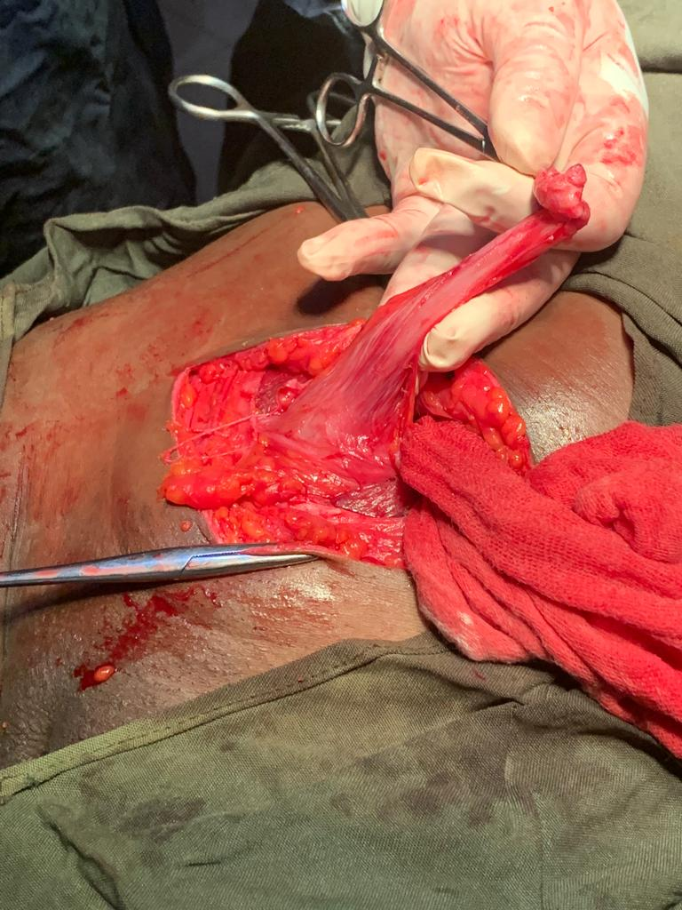

Fig. 2:The urachus severed from the umbilicus.

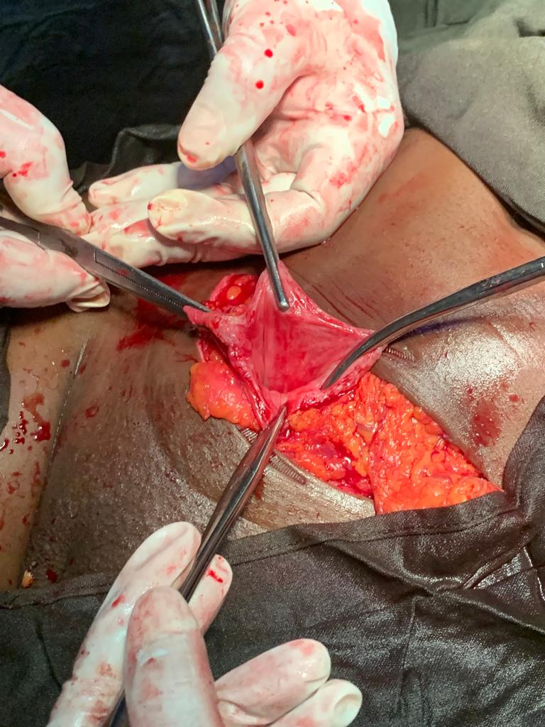

Fig.3: The bladder following partial cystectomy with urachus excised.

**Discussion**: The urachus is a fibrous cord arising from the early fetal anterior bladder wall to the allantois, extending cranially to the umbilicus. It undergoes many developmental changes during embryonic life and finally descends along with the bladder in the pelvis. This descent stretches the urachus leading to the obliteration of its lumen and the formation of a fibrous band known as the median umbilical ligament.**5**It is the failure of obliteration of this, that leads to the formation of the various urachal anomalies.

Urachal anomalies are divided into 2 groups: congenital and acquired. Patent urachus is usually congenital.**6** Patent urachus is usually detected at birth or in infancy, therefore congenital patent urachus in an adult (more than 20 years old) is very rare.**7,8** The persistence of the urachus was first described and treated in 1550 by Cabrolius as mentioned by Begg.**9** Collectively, the urachus is formed by remnants of the cloaca and the allantois and so their remnants are formed due to incomplete regression of the intra-embryonic connection between them.**10,11**Congenital causes of urachal anomalies can be further subdivided into: patent urachus, umbilical-urachal sinus, vesicourachal diverticulum, urachal cyst, and alternating sinus.**12**Acquired urachal remnant diseases are classified into two groups: infections and neoplasms.**13** Among the congenital urachal anomalies, except patent urachus, the remaining four anomalies may close at birth but can reopen after pathological conditions and therefore may be classified as acquired urachal remnant diseases.**14** The incidence of patent urachus is 3 in 1,000,000 live births and is even rare in adults.**15** Patent urachus is commoner in males.**16** Recurrent acute urinary retention due to Benign Prostatic Hyperplasia could lead to the development of a leaking urachal fistula in men.**17**

Our patient is not only an adult, she is also a female. Mostly the patient presents with umbilical discharge and its complications like infection, urinary tract infection, umbilical cellulitis, intraperitoneal rupture, bowel fistulae, bleeding and most severe the neoplastic lesions due to chronic inflammation. Therefore, patent urachus is often misdiagnosed as appendicitis, Meckel’s diverticulitis, urinary tract infection, pelvic inflammatory disease, and bladder carcinoma.**18**

Our patient presented with umbilical wetness upon straining to urinate. Physical examination revealed nothing other than wetness upon straining with a full bladder. There were no areas of induration.

Investigations for patent urachus include abdominopelvic ultrasound and micturating cystourethrogram.**19** The indigo carmine dye discharge test and fistulography are diagnostic of patent urachus.**7,20** Computed tomography scan remains the investigation of choice for suspected cases while longitudinal ultrasound, indigocarmine dye discharge test or fistulography are other means to diagnose the disease.**21** In our case, a micturating cystourethrogram was done which demonstrated a fistulous tract between the bladder dome and the umbilicus, however, the patient had misplaced the film as at the time of writing this report.

The treatment is urachal resection and partial cystectomy. We believe that surgery is necessary in the case of patent urachus in an adult especially because of the risk of the urachal cancer.**2** Our patient had resection of the urachus with a cuff of bladder dome. The bladder defect was closed. A urethral catheter was left in situ for ten days. The post operative period was uneventful and patient subsequently stopped experiencing wetness at her navel. The resected urachus and bladder cuff were sent for histopathological examination. Fig. 4.

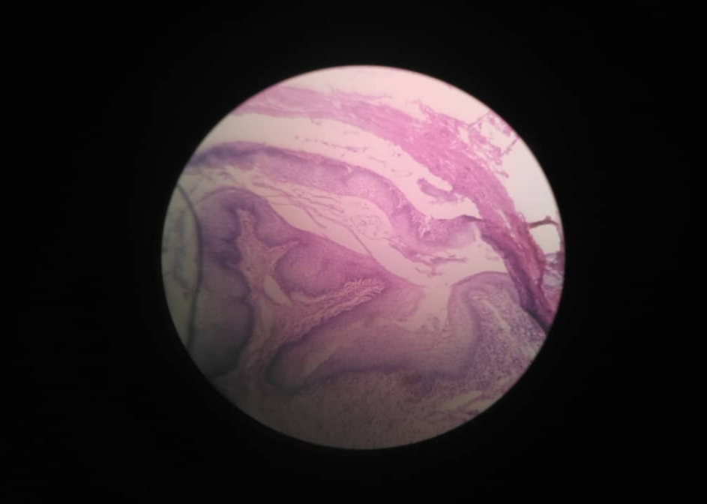

Fig. 4: Histologic section of the bladder showing the urachus.

The epithelium is stratified columnar epithelium and urothelium. No areas of cellular atypia or malignancy.

**Conclusion:** Congenital patent urachus in adults is very rare. A combination of its rarity, nonspecific presentations and reluctance of adult patients to present due to shyness makes diagnosis further delayed.

A high index of suspicion is necessary in order to make early diagnosis and institute treatment to avoid complications ranging from repeated infections to malignant transformation.

**References**:

1. Takano Y, Okatani K, Okamoto S, Enoki N. Congenital patent urachus in an adult: a case report. International journal of urology. 1994 Sep;1(3):275-7.

2. Wilmoth CL. Persistent urachus in the adult. JAMA. 1936;106:526-529

3. Hinman F Jr. Surgical disorders of the bladder and umbilicus of urachal origin. Surg GynecolObstet 1961;113:605-614

4. Parada Villavicencio C, Adam SZ, Nikolaidis P, Yaghmai V, Miller FH. Imaging of the urachus: anomalies, complications, and mimics. Radiographics. 2016 Nov;36(7):2049-63.

5. Fode M, Pedersen GL, Azawi N. Symptomatic urachal remnants: case series with results of a robot-assisted laparoscopic approach with primary umbilicoplasty. Scandinavian Journal of Urology. 2016 Nov 1;50(6):463-7.

6. Blichert-Toft M, Nielsen OV. Diseases of the urachus simulating intra-abdominal disorders. Am J Surg. 1971;122:123- 128.

7. Buckspan MB. Patent urachus and infected urachal cyst in an adult: A case report. Can J Surg. 1984;27:496-499.

8. Ward TT, Saltzman E, Chiang S. Infected urachal remnants in the adult: Case report and review. Clin Infect Dis 1993;16:26-29

9. Ueno T, Hashimoto H, Yokoyama H, Ito M, Kouda K, Kanamaru H. Urachal anomalies: ultrasonography and management. J Pediatr Surg. 2003;38:1203-7.

10. Blichert-Toft M, Nielsen OV. Congenital patent urachus and acquired variants. Diagnosis and treatment: review of the literature and report of five cases. Acta Chir Scand. 1971;137:807-14.

11. Renard O, Robert G, Guillot P, Pasticier G, Roche JB, Benhard JC, et al. Benign urachus abnormalities: embryology, diagnosis and treatments. Prog Urol. 2008;18(10):634-41.

12. Severson CR. Enhancing nurse practitioner understanding of urachal anomalies. J Am Acad Nurse Pract. 2011;23(1):2-7.

13. Ashley RA, Inman BA, Routh JC, Rohlinger AL, Husmann DA, Kramer SA. Urachal anomalies: a longitudinal study of urachal remnants in children and adults. J Urol. 2007;178(4):1615-8.

14. Srivastava VK, Roy S, Meena RN, Khanna R. Urachal fistula in a 22-year male: a case report. International Surgery Journal. 2020 Aug 27;7(9):3102-4.

15. Sherman JM, Rocker J, Rakovchik E. Her belly button is leaking: a case of patent urachus. Pediatr Emerg Care. 2015;31(3):202-4.

16. Gleason JM, Bowlin PR, Bagli DJ, Lorenzo AJ, Hassouna T, Koyle MA, Farhat WA. A comprehensive review of pediatric urachal anomalies and predictive analysis for adult urachal adenocarcinoma. J Urol. 2015 Feb;193(2):632-6.

17. Amu OC, Affusim EA, Nnadozie UU, Eze BU. Development of a Leaking Urachal Fistula in A BPH Patient with Recurrent Acute Urinary Retention: A Case Report. Transformation. 2021 Oct 20;11:13.

18. Mrad DK, Ben RS, Zaghbib S, Oueslati A, Gharbi M, Nouira Y. Infected urachal cyst in an adult: a case report. Urology Case Reports. 2019;26:100976.

19.Yapo BR, Gerges B, Holland AJ. Investigation and management of suspected urachal anomalies in children. Pediatr Surg Int. 2008 May;24(5):589-92.

20. Berman SM, Reid RE,Tolia BM, Schweizerhof SP, Laor E, Freed SZ. Urachal remnants in adults. Urology. 1988;31:17-21

21. Bertozzi M, Recchia N, Di Cara G, Riccioni S, Rinaldi VE, Esposito S, Appignaniet A. Ultrasonographic diagnosis and minimally invasive treatment of a patent urachus associated with a patent omphalomesenteric duct in a newborn: a case report. Medicine (Baltim.) 2017;96(30):7087.